**Introduction:**   
In the digital age, a high-quality website is the cornerstone of any company's online presence, acting as the first impression for potential customers. Berimbolo Security recognizes this, and their website needs go beyond aesthetics. Functionality, user experience, and catering to their target audience in Egypt are equally important. To achieve this, valuable insights can be gleaned from successful security company websites.

This report offers a comparative analysis of two such websites: Smart Services Security and Frontpoint Security. We'll assess their design elements, features, target audience suitability, and adherence to web design principles. Through this examination, we aim to provide Berimbolo Security with the knowledge needed to craft a website that meets their business goals and resonates with their users, fostering trust and engagement in the competitive Egyptian security services market.  
  
**Compare the design and features of the identified websites:**  
  
**1. Smart Services Egypt:  
  
Summary:** Smart Services Egypt offers security solutions for homes, businesses, and industries in Egypt. Their website is available in Arabic.  
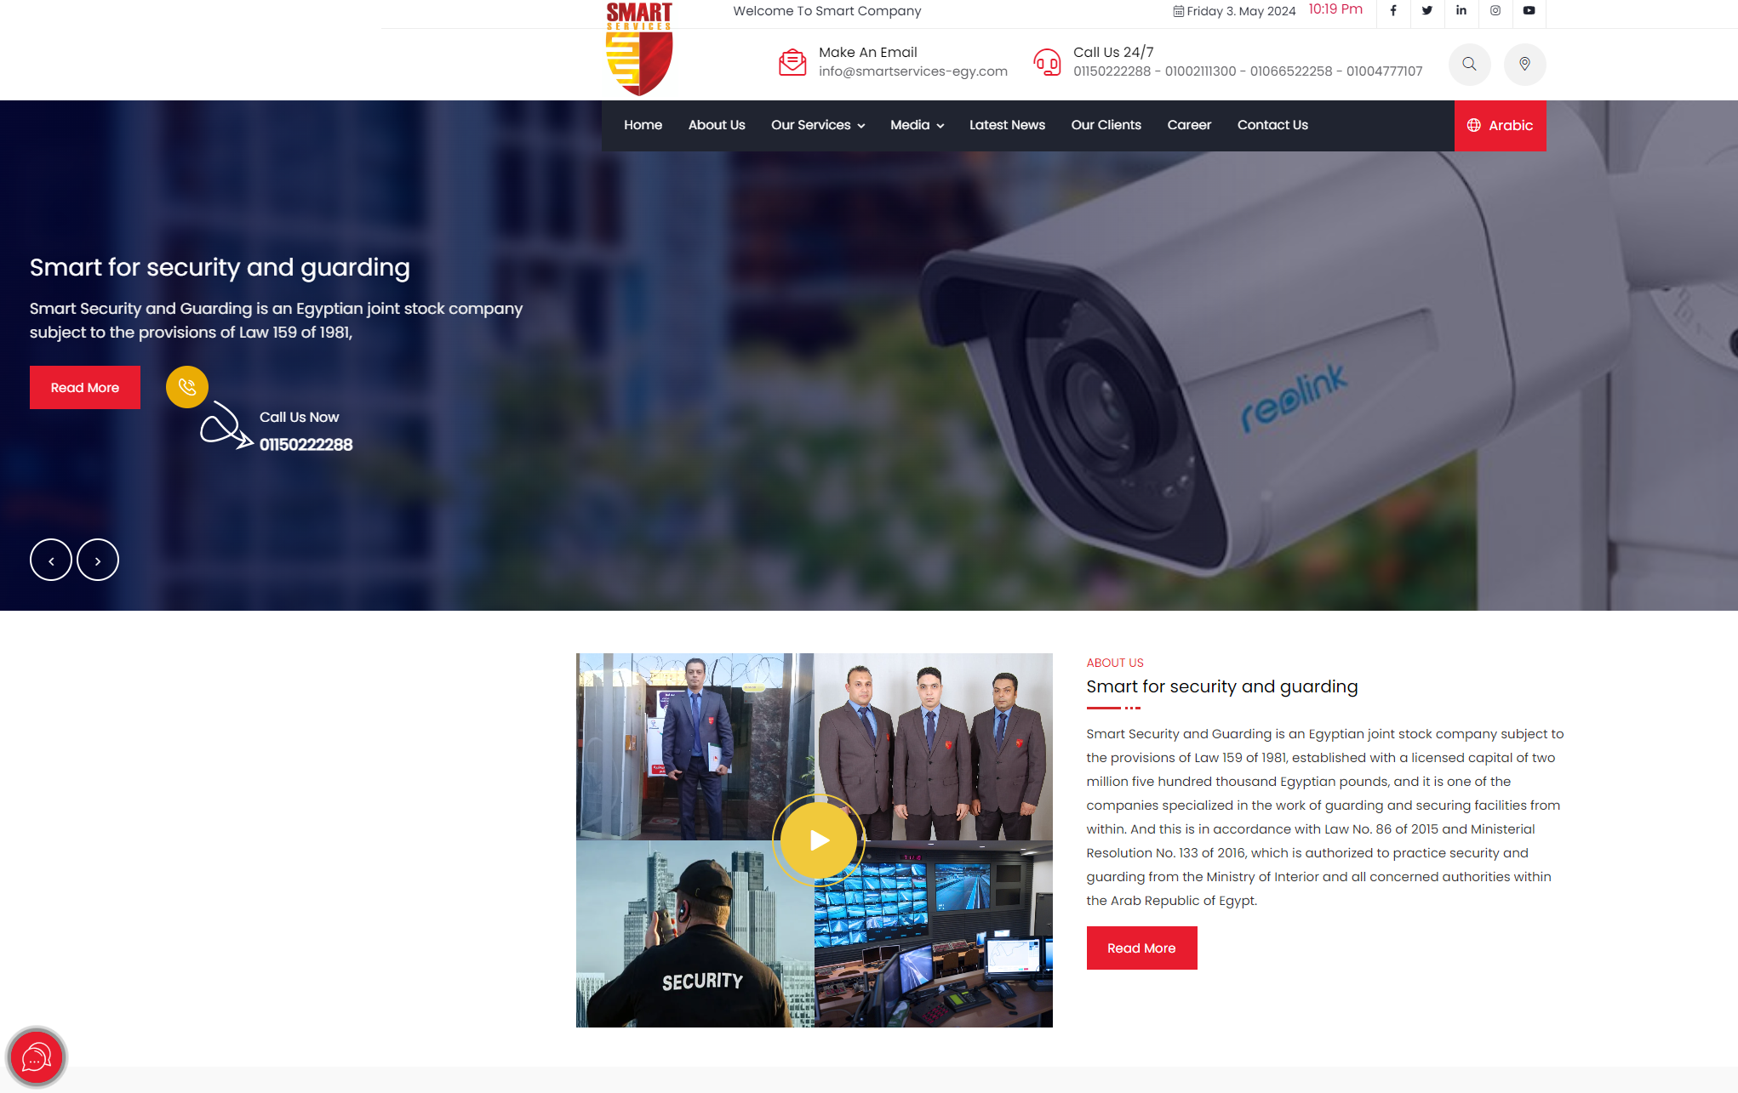The Egyptian website initially presents a comprehensive view of its services, providing clear information about what the site offers. The website has a clean and professional design with a focus on high-quality images and videos. The navigation bar is clear and easy to use, offering options in Arabic, which enhances accessibility for the local audience. However, upon closer inspection, the theme and color scheme appear lacking in appeal.  
  
**Features:**

* Information on security systems (CCTV, intrusion alarms), fire alarms, access control systems, and home automation solutions.
* Project gallery of past installations in Egypt, demonstrating their capabilities.
* Client testimonials in Arabic, fostering trust with potential customers.
* Contact information and a contact form for inquiries.

**Suitability for Audience:**  This website caters well to Arabic-speaking audiences in Egypt looking for various security solutions for their homes and businesses.  
  
**Web Design and Development Principles:**

**Clear Hierarchy:** Information is organized logically with a clear hierarchy, making navigation easy for users.

**High-Quality Visuals:** The website effectively utilizes high-quality images and videos to showcase their services and past projects, allowing potential customers to visualize their security solutions.

**Mobile-First Design:** The website appears responsive and adjusts to different screen sizes, ensuring a positive user experience on mobile devices.

**Evaluation:**

**Positives:** The website is visually appealing, informative in Arabic, and provides clear calls to action for potential customers to contact them.

**Negatives:** Limited information on specific services and pricing might require users to contact them directly. The website could benefit from including:

**Detailed Service Pages:** In-depth information on each security system, highlighting features, benefits, and technical specifications.

**Case Studies:** Demonstrating expertise by showcasing successful security solutions implemented for past clients.

**Security Blog (Optional):** Providing valuable content on security best practices, industry trends, and new technologies can attract organic traffic and establish Berimbolo Security as a thought leader.

**2. Frontpoint Security (https://www.frontpointsecurity.com/)**

**Summary:** Frontpoint Security, a US-based company, offers home security systems with 24/7 professional monitoring.

**Design:** The website has a modern and user-friendly design with a focus on clear calls to action.

* **Features:**  
  Interactive features like a "Get a Quote" tool and security system customization options.
* Detailed information on security packages, monitoring plans, and smart home integration capabilities.
* Educational resources on home security best practices.
* Customer reviews and testimonials.

**Suitability for Audience:** This website caters primarily to homeowners in the US looking for comprehensive home security solutions with professional monitoring.

**Web Design and Development Principles:**

**Interactive Elements:** The website engages users and personalizes their experience through interactive features like the quote tool and system customization options.

**Compelling Content:** Content is clear, informative, and effectively highlights the benefits of Frontpoint's security solutions.

**Calls to Action:** Clear calls to action are strategically placed throughout the website, encouraging users to get a quote or learn more.

**Evaluation:**  
**Positives:** The website is informative, engaging, and empowers users with tools to make informed decisions.

**Negatives:** The website is US-focused and may not directly translate to Berimbolo Security's target audience in Egypt.

**Analysis of Web Design and Development Principles**

This section will delve deeper into how Smart Services Egypt and Frontpoint Security leverage web design and development principles to achieve their website goals.

**Smart Services Egypt:**

* **Clear Hierarchy:** The website employs a clear and logical information architecture. Content is organized intuitively, making navigation effortless for users. This is achieved through a well-structured navigation bar and proper use of headings and subheadings.
* **High-Quality Visuals:** Smart Services Egypt leverages high-quality images and videos to showcase their security systems and past installations. This visual storytelling approach allows potential customers to see their security solutions in action and understand their real-world applications.
* **Mobile-First Design:** In today's mobile-centric world, ensuring a responsive website design is crucial. Smart Services Egypt's website adapts to different screen sizes, guaranteeing a positive user experience on desktops, tablets, and mobile devices. This caters to users who might be searching for security solutions while on the go.

**Frontpoint Security:**

* **Interactive Elements:** Frontpoint Security utilizes interactive features like a "Get a Quote" tool and security system customization options. These interactive elements engage users, personalize their experience, and empower them to explore solutions that meet their specific needs.
* **Compelling Content:** The website features clear, informative content that effectively highlights the benefits of Frontpoint's security solutions. This content is likely well-researched and targeted towards homeowner concerns, addressing pain points and emphasizing how their services provide security and peace of mind.
* **Calls to Action (CTAs):** Strategic placement of clear CTAs throughout the website encourages users to take action. These CTAs might prompt users to get a quote, learn more about specific features, or contact Frontpoint Security directly.

**Additional Considerations:**

* **Search Engine Optimization (SEO):** While not explicitly mentioned in the website analysis, SEO best practices likely play a role in both websites. Optimizing website content with relevant keywords can improve search engine ranking and increase organic traffic.
* **Accessibility:** Accessibility ensures websites are usable by everyone, regardless of ability. While not always readily apparent to users, features like proper use of alt text for images and keyboard navigation options can contribute to a website's accessibility.

**Evaluation of Website Needs Fulfillment**

**Smart Services Egypt**

**Website Owner Needs:**

* **Meeting User Needs:** The website partially meets user needs by providing a clear overview of services and contact information. However, limited details on specific services and pricing might require users to contact them directly, potentially hindering conversions.
* **Lead Generation:** The website offers a contact form, but could be enhanced with stronger CTAs and additional lead capture mechanisms (e.g., downloadable resources gated by email capture).
* **Brand Image:** The clean design and Arabic content project a professional image. However, including case studies or white papers could further establish their expertise.

**User Needs:**

* **Information Gathering:** The website provides a good starting point for information gathering on security solutions. However, users might need to contact them for in-depth details.
* **User Experience:** The user experience is positive due to the clear hierarchy, mobile-friendliness, and high-quality visuals.
* **Taking Action:** The website offers a clear call to action (contact form) but could benefit from additional options like a quote request form or a live chat feature.

**Overall Evaluation:**

Smart Services Egypt's website meets some website owner needs by creating a professional first impression. However, it could be improved to better capture leads and meet user needs for detailed information and convenient ways to take action.

**Frontpoint Security**

**Website Owner Needs:**

* **Meeting User Needs:** The website effectively addresses user needs by providing detailed information, interactive features, and clear CTAs. This likely leads to a higher conversion rate.
* **Lead Generation:** Strong CTAs and interactive tools like the quote tool effectively capture leads.
* **Brand Image:** The modern design and informative content project a trustworthy and innovative brand image.

**User Needs:**

* **Information Gathering:** The website provides comprehensive information on security packages, monitoring plans, and even educational resources, catering well to user needs.
* **User Experience:** The user experience is engaging due to the interactive elements and clear CTAs.
* **Taking Action:** The website provides clear and multiple ways for users to take action, such as getting a quote or contacting customer support.

**Overall Evaluation:**

Frontpoint Security's website excels at meeting both website owner and user needs. The website design, content, and features are well-aligned to capture leads and guide users through the decision-making process. However, it's important to remember that this website targets the US market, and its focus on professional monitoring might not be directly relevant to Berimbolo Security's audience in Egypt.

**Key Takeaways for Berimbolo Security**

By analyzing both websites, Berimbolo Security can learn valuable lessons to optimize their website for the Egyptian market:

**Balance User Needs with Business Goals:** Provide detailed information on services while incorporating engaging CTAs to capture leads.

**Prioritize User Experience:** Maintain a clean, mobile-friendly design and leverage visuals to showcase installations in Egypt.

**Cater to Local Needs:** Focus on security solutions relevant to the Egyptian market and ensure Arabic content prioritizes local search terms.

**Use specific examples of these to support the points:**I'm considering integrating the strengths of both websites, Smart Services Egypt and Frontpoint Security, into the website for Berimbolo Security. This includes features like a live agent chat, a more user-friendly interface, bilingual support in Arabic and English on the same website, and additional elements aimed at providing customers with the best possible user experience.